Pollen's Profiling: Automated Classification of Pollen Grains

1. Introduction

• Project Title: Pollen's Profiling: Automated Classification of Pollen Grains
• Team Members: Team Leader: Sriram Sree Lakshmi
Team member: Shaik Nayeem
Team member: Shakina Dasari
Team member: Shaik Shakira
2. Project Overview
• Purpose: This project aims to build a web-based system where users can upload pollen grain images and automatically classify them using a deep learning model. The system helps researchers, students, and agriculturists quickly identify pollen types with accuracy.
• Features:
- Image upload and classification through a trained CNN model
- Display of prediction results with confidence score
- Clean web interface built using HTML and CSS
- Python-based backend with Flask framework
- Option to preview image and download results
3. Architecture
• Frontend:
Implemented using HTML and CSS. The UI includes pages for image upload and result display. All pages are served from Flask via Jinja2 templates.
• Backend:
Developed using Python and Flask. The server handles HTTP requests, performs image processing, calls the ML model for classification, and renders the results to the frontend.
• Model:
The CNN model is implemented in Python using TensorFlow/Keras. It takes a pollen grain image as input and returns the predicted class and confidence level.
4. Setup Instructions
• Prerequisites:
- Python 3.8+
- pip
- Flask
- TensorFlow / Keras
• Installation:
# Clone the repository
git clone :https://github.com/Shaik-Shakira/Pollen_Profiling.git

# Navigate into the project
cd pollen-profiling-flask

# Install Python dependencies
pip install -r requirements.txt
5. Folder Structure
pollen_classifier_web/
│
├── app.py # Main Flask application
│
├── model/
│ └── Training_model.py # Python script to train/load CNN model
│
├── static/
│ └── style.css # Optional custom styling for the site
│
├── templates/ # HTML templates served by Flask
│ ├── index.html # Homepage with image upload
│ ├── prediction.html # Displays model's prediction result
│ ├── logout.html # Logout / session-end page
│ └── example_image.jpg # Example pollen image for UI preview (can be replaced)
│
└── uploads/ # Stores user-uploaded images during runtime
└── (user uploaded images)
6. Running the Application
# Start the Flask server
python app.py
Visit http://127.0.0.1:5000 in your browser to use the app.
7. API Documentation:
- User visits the homepage and uploads an image.
- Flask receives the image and saves it.
- The image is passed to the CNN model for classification.
- Result page is rendered with prediction and confidence.8. AuthenticationAuthentication is handled using JWT (JSON Web Tokens). Tokens are issued upon successful login and stored in the client (localStorage). Protected routes verify tokens via middleware. Passwords are hashed using bcrypt.
8. Authentication:
Currently, there is no authentication in this version. Future versions may include basic login features.
9. User Interface
Developed with HTML5 and CSS3
Responsive and user-friendly layout
Two main pages: Index page and Prediction page
10. Testing
Backend Testing: Manual test of image uploads and model inference
Model Testing: Validate model predictions on sample pollen dataset
11. Screenshots or Demo:
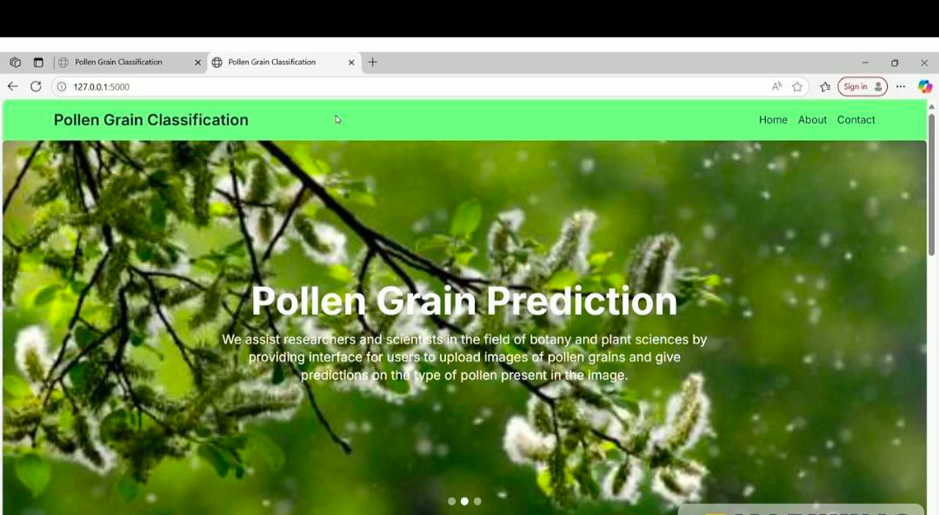
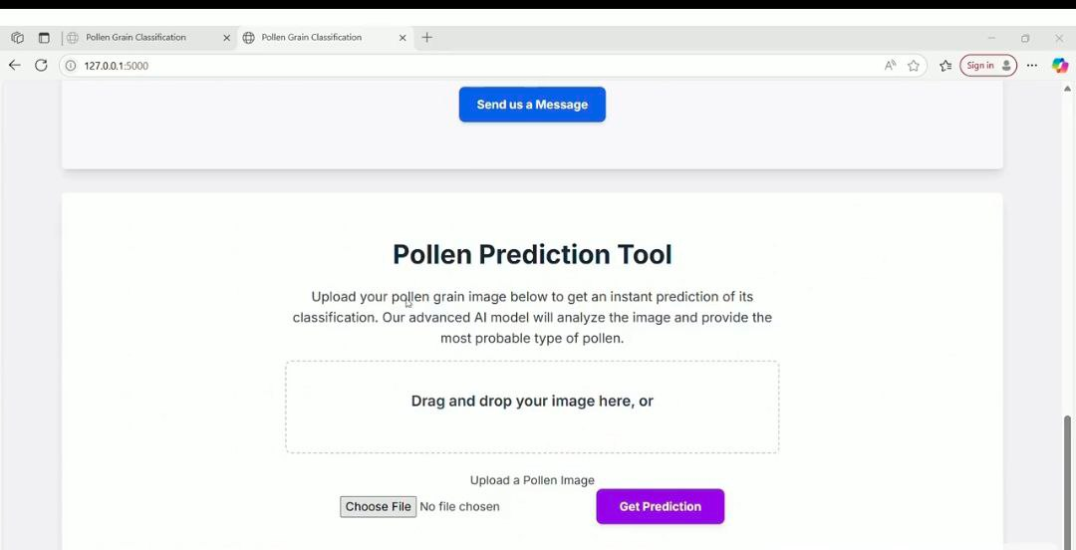

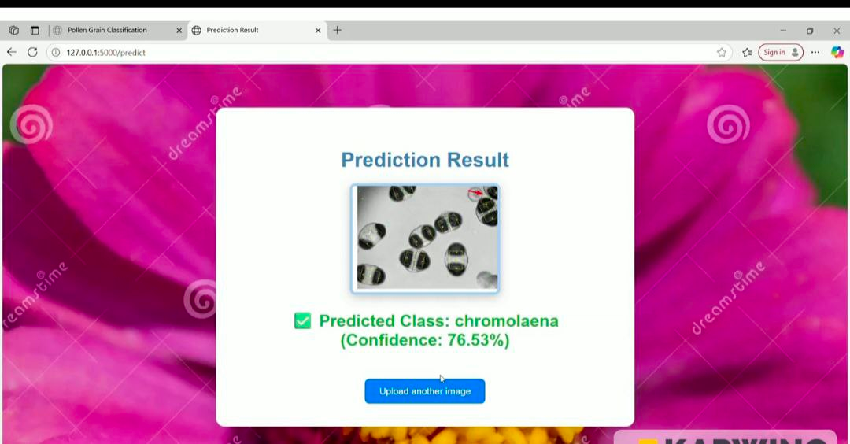
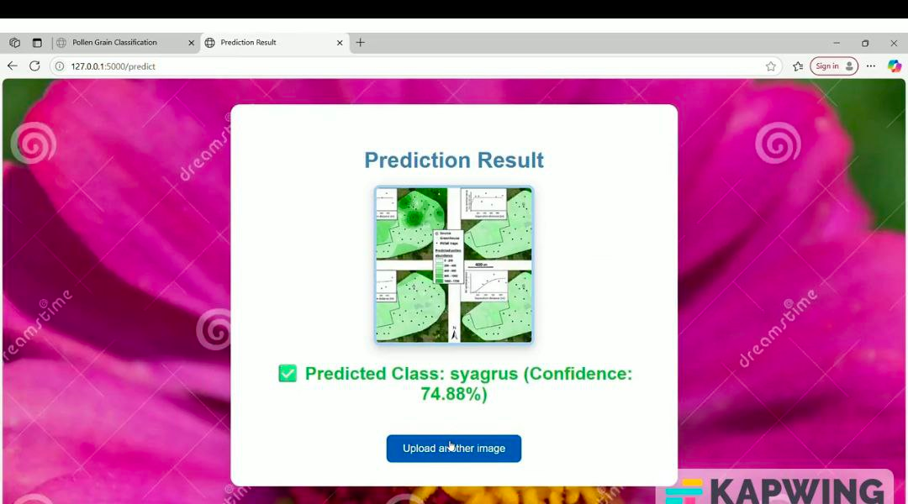

12. Known Issues:
- Gmail/LinkedIn OAuth may require valid client IDs in production
- Prediction model is CPU-based, so slower on large images
- No pagination in history (to be added)

13. Future Enhancements:
- Add pagination and filters for prediction history
- Enable drag & drop image uploads
- Integrate email notification on prediction results
- Add training module for uploading new pollen categories
- Migrate model inference to a TensorFlow Serving API

